POWER BI PROJECT

- Firstly, I should mention that this project was created based on “Alex The Analyst” courses. The data used here coming from real-life survey regarding Data Analytics jobs among hundreds of different people. Planned to be cleaned only using Power BI.
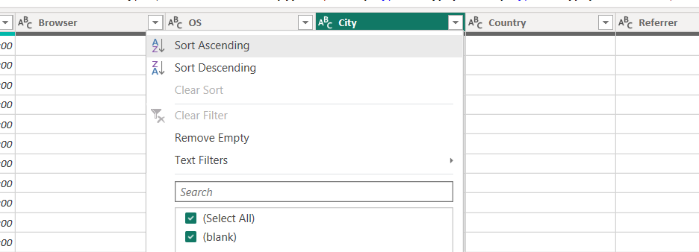
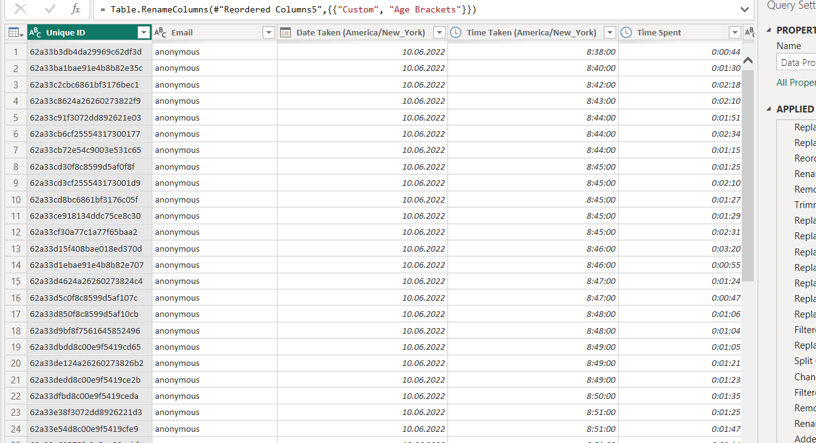
- There is a lot of data that need cleaning, from what I see. Several columns can be deleted as well.
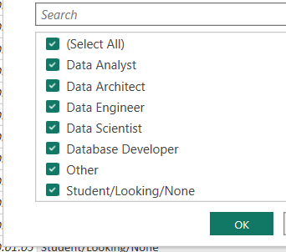
- Column named “Which title best fits your role?” has a lot of positions with different job titles, but it’s gonna be cleaned now – cleaning just the job titles from “Other (Please specify):” text, by using delimiter, replacing values and Trim function to delete start spaces.
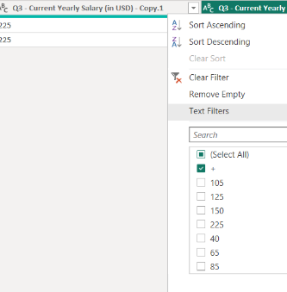
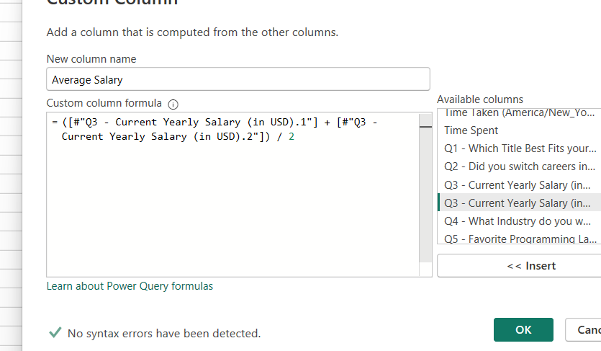
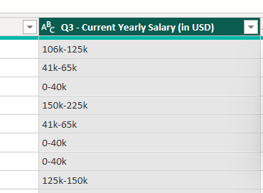
- Cleaning the salary ranges to be more usable. Creating clone column. Spliting by Digit to non-digit. Replacing the useless signs and letters. Adding and dividing SUM by 2 to find the average salary for each range in Custom column.
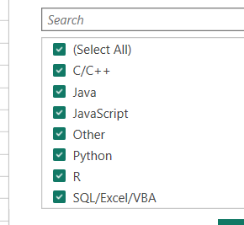
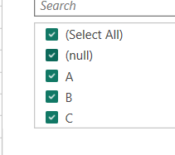
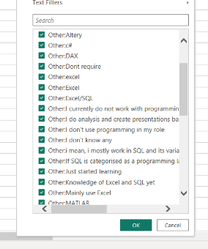
- There was a question about mostly used programming language, but there were also ETLs. So I decided to combine them to one separate category, but all the others keep as Other. I replaced the values as A, B, C with “ “ accordingly and then placed under one naming.
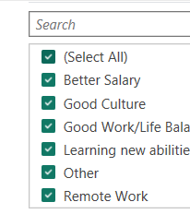
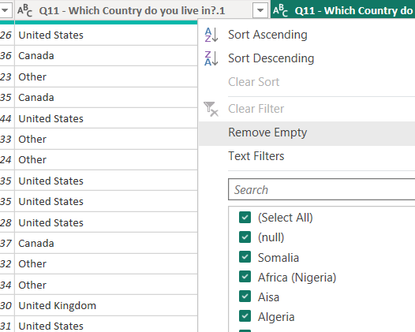
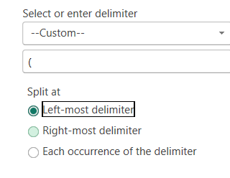
- Some other columns as well.
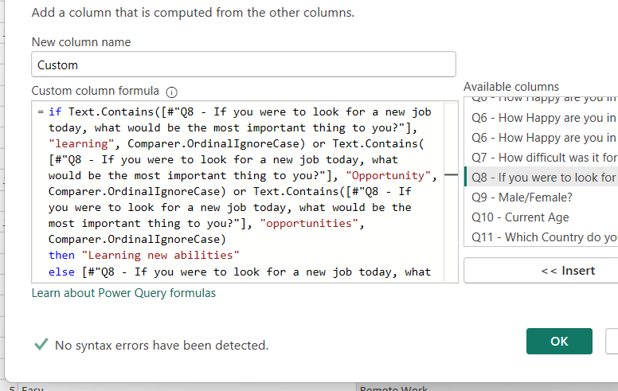
  - At some point my project crashed and I had to start doing it all over again. But at this moment I wanted to add even more editing here. For example, to the question Q8 about the reasons why would person change the job, based on answers under Other category, I saw some repeatings that were similar to themselves. So I decided to use Power Query in new column and use IF statement wit OR and Text.Contains which worked just fine!
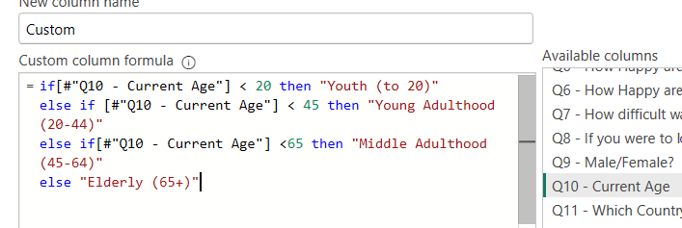
  - Decided to make Current Age column more usable. Power Query that works on IF ELSE statement.
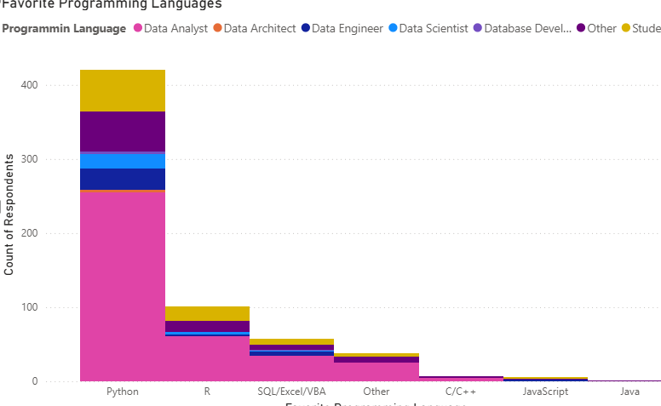
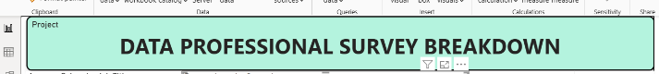
- I can start now with visualization. The title. Visual of Avg Salary per Job title. People’s favourite programming languages.
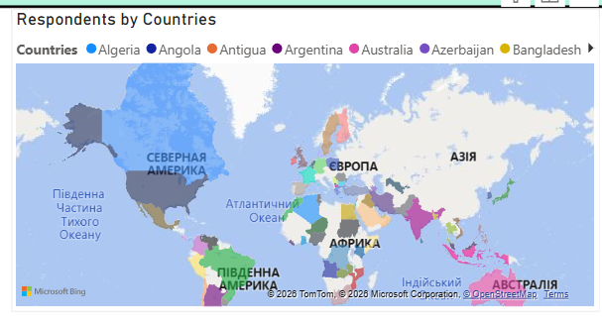
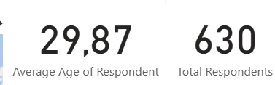
  - Average Age & Total Survey Takers. A Map of where the respondens are from.
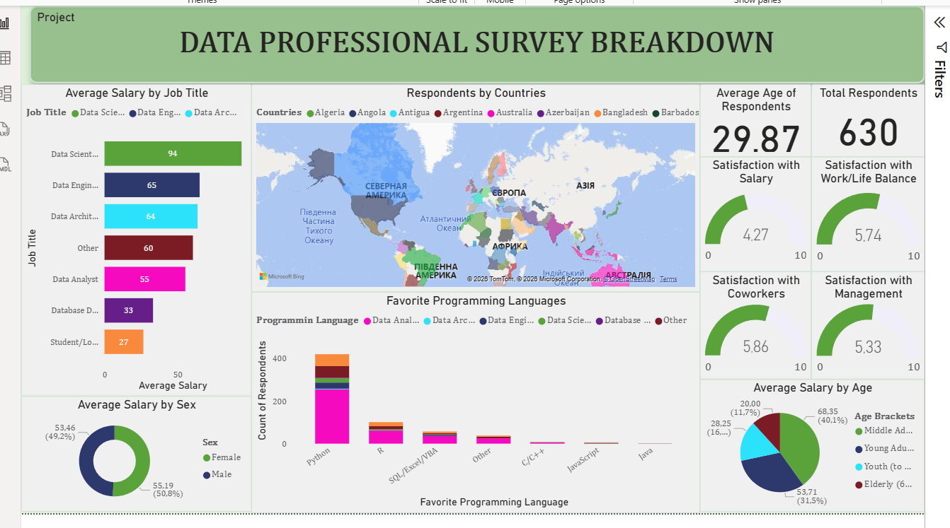
- I added several more visualizations here – and that’s how the final Dashboard looks like!

